TC-CMS-028
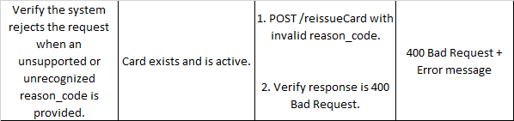
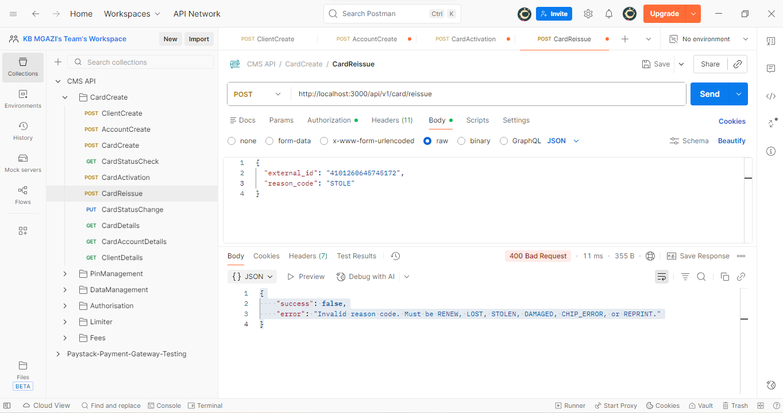
Request:
{
"external_id": "4101260645745172",
"reason_code": "STOLE"
}

Response:
{
"success": false,
"error": "Invalid reason code. Must be RENEW, LOST, STOLEN, DAMAGED, CHIP_ERROR, or REPRINT."
}

